**Project Development Phase**

**Delivery of Sprint-1**

| **Team ID** | PNT2022TMID09234 |
| --- | --- |
| **Project Title** | Retail Store Stock Inventory Analytics |

**Project Development Phase:**

| **SPRINT-1** | * Data Collection * Data Preparation |
| --- | --- |
| **SPRINT-2** | * Data Exploration |
| **SPRINT-3** | * Dashboard Creation |
| **SPRINT-4** | * Report Creation * Story Creation |

**Project Contributors:**

* Adithya Nagaraj R (310619104004)
* Imran Khan S (310619104041)
* Kamaleshwaran P (310619104050)
* Karthick S (310619104053)

**Sprint - 1:**

**Data Collection:**

Download the Dataset

**Dataset link** - [https://drive.google.com/drive/folders/1kiL-5CHJmQvbk9VyFsuUs-myAupBZGNy](https://drive.google.com/drive/folders/1kiL-)

**Load the Dataset:**

Tool used – IBM Cognos

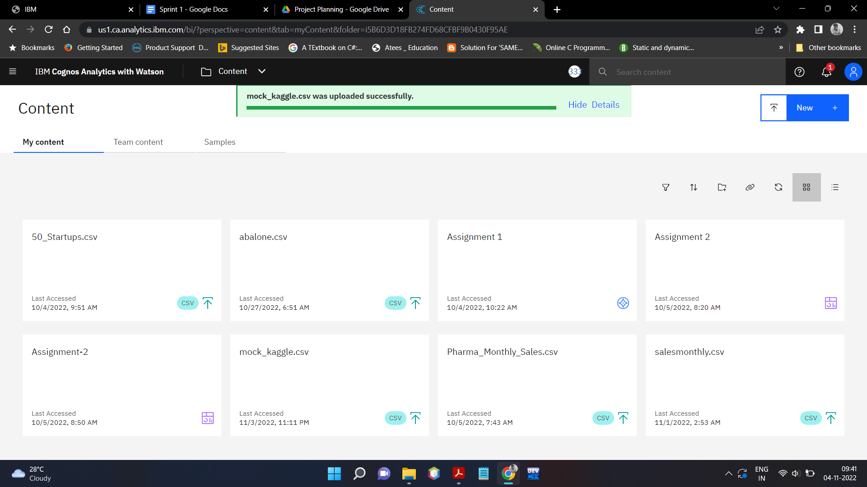

**Creating New Module:**

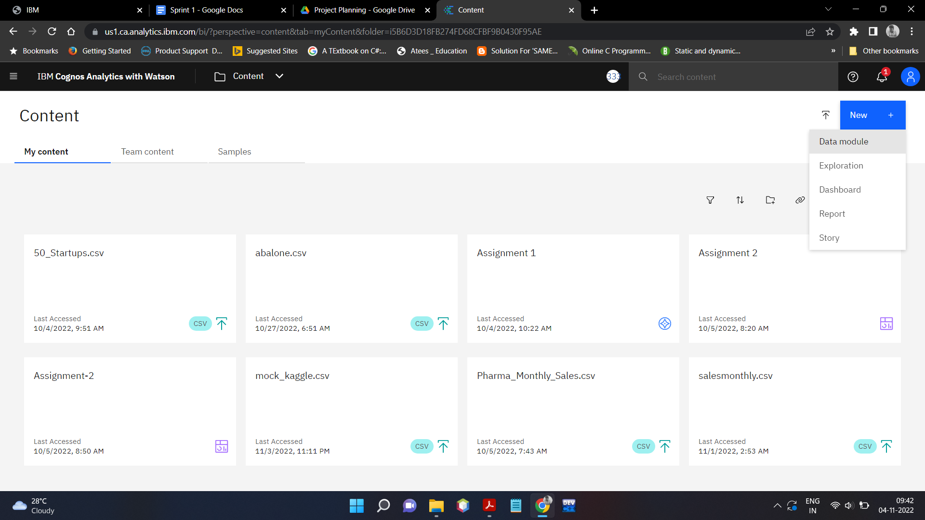

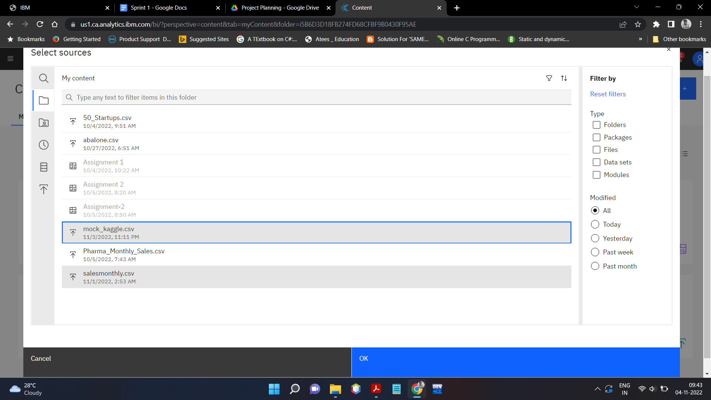

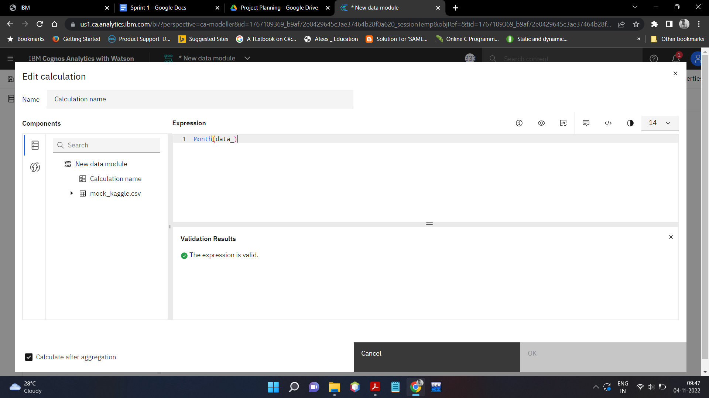

**Month Data:**

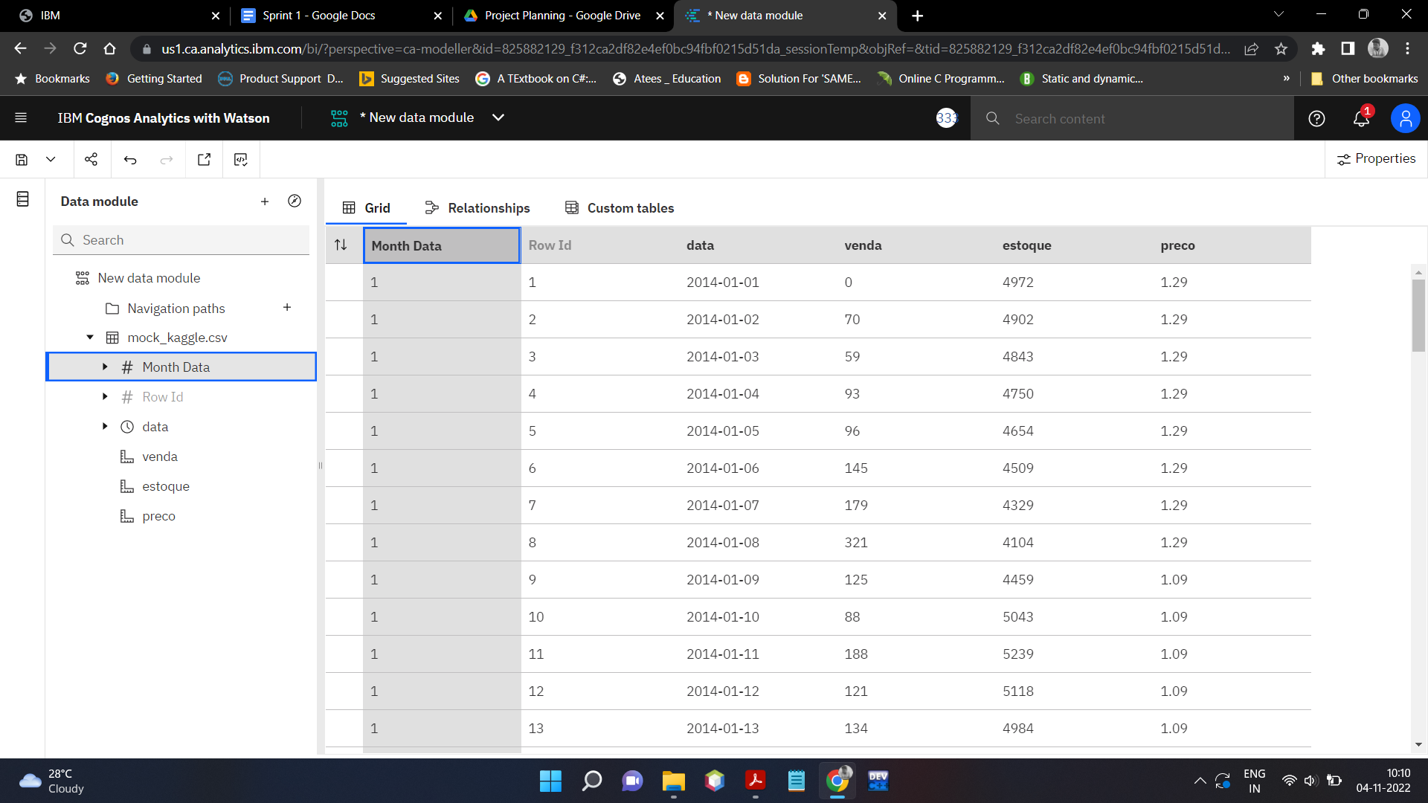

**Revenue Data:**

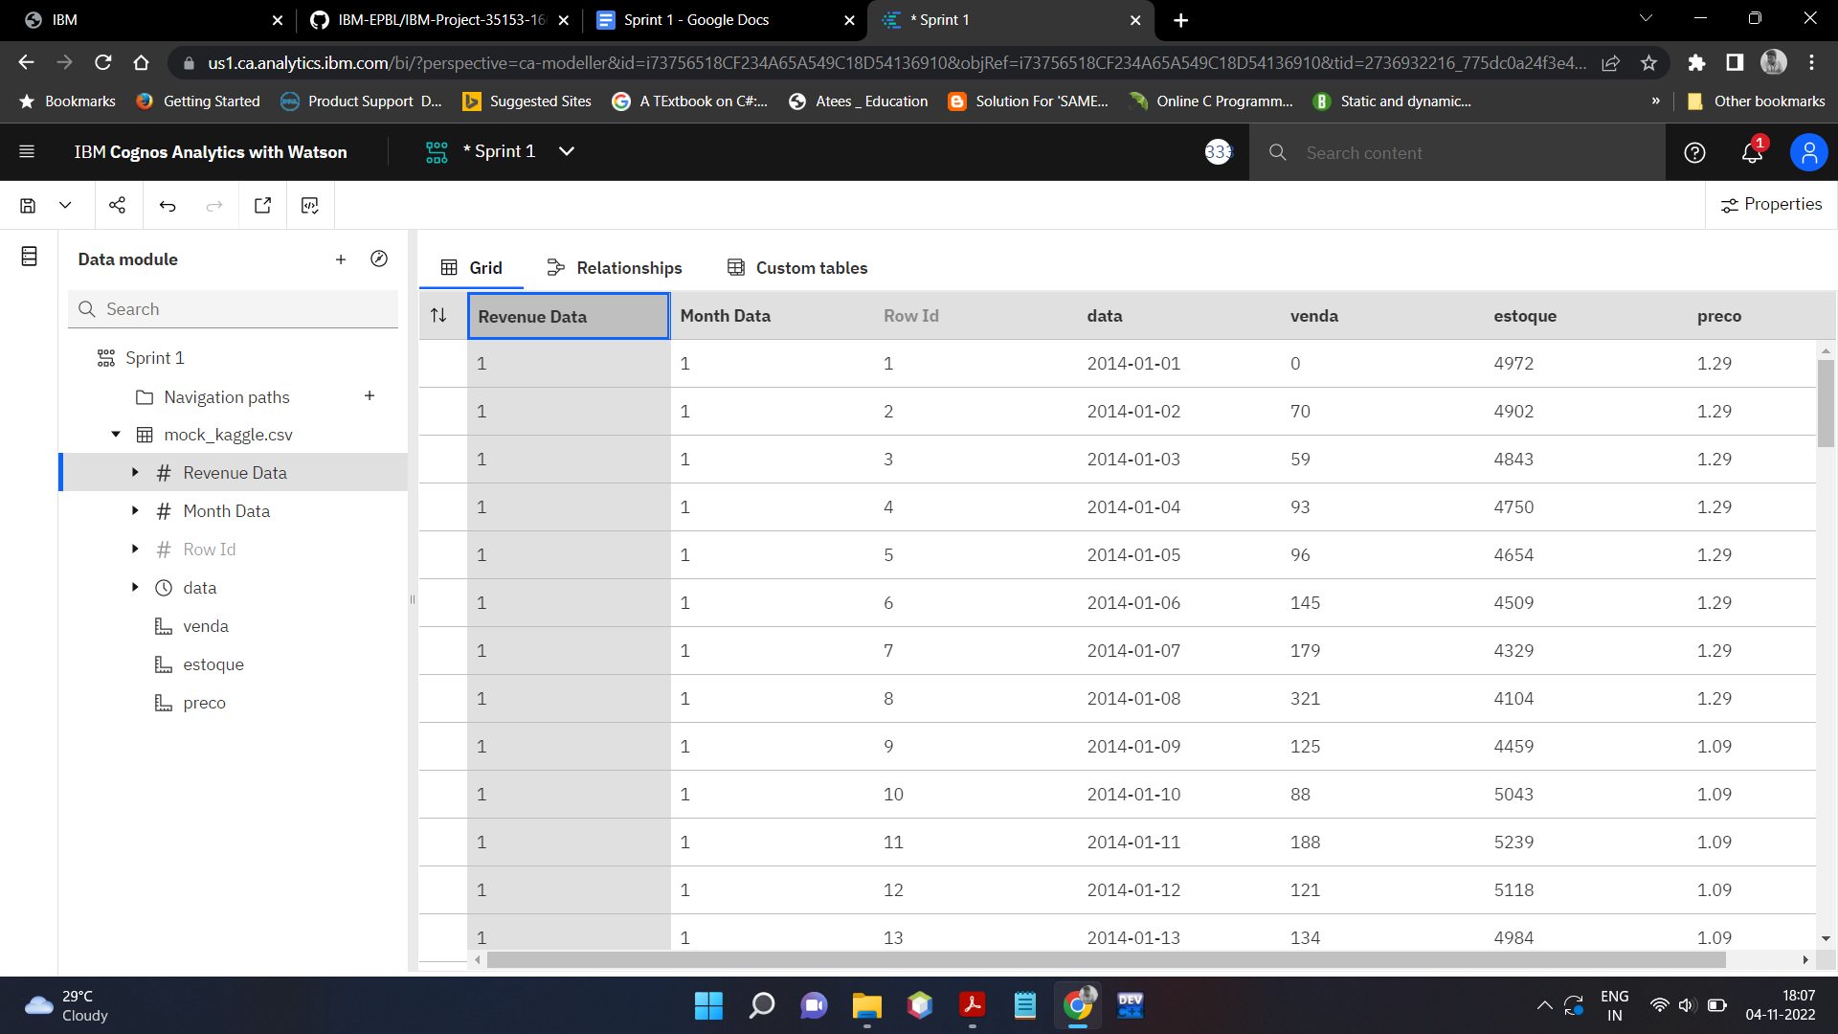

**Year Data:**

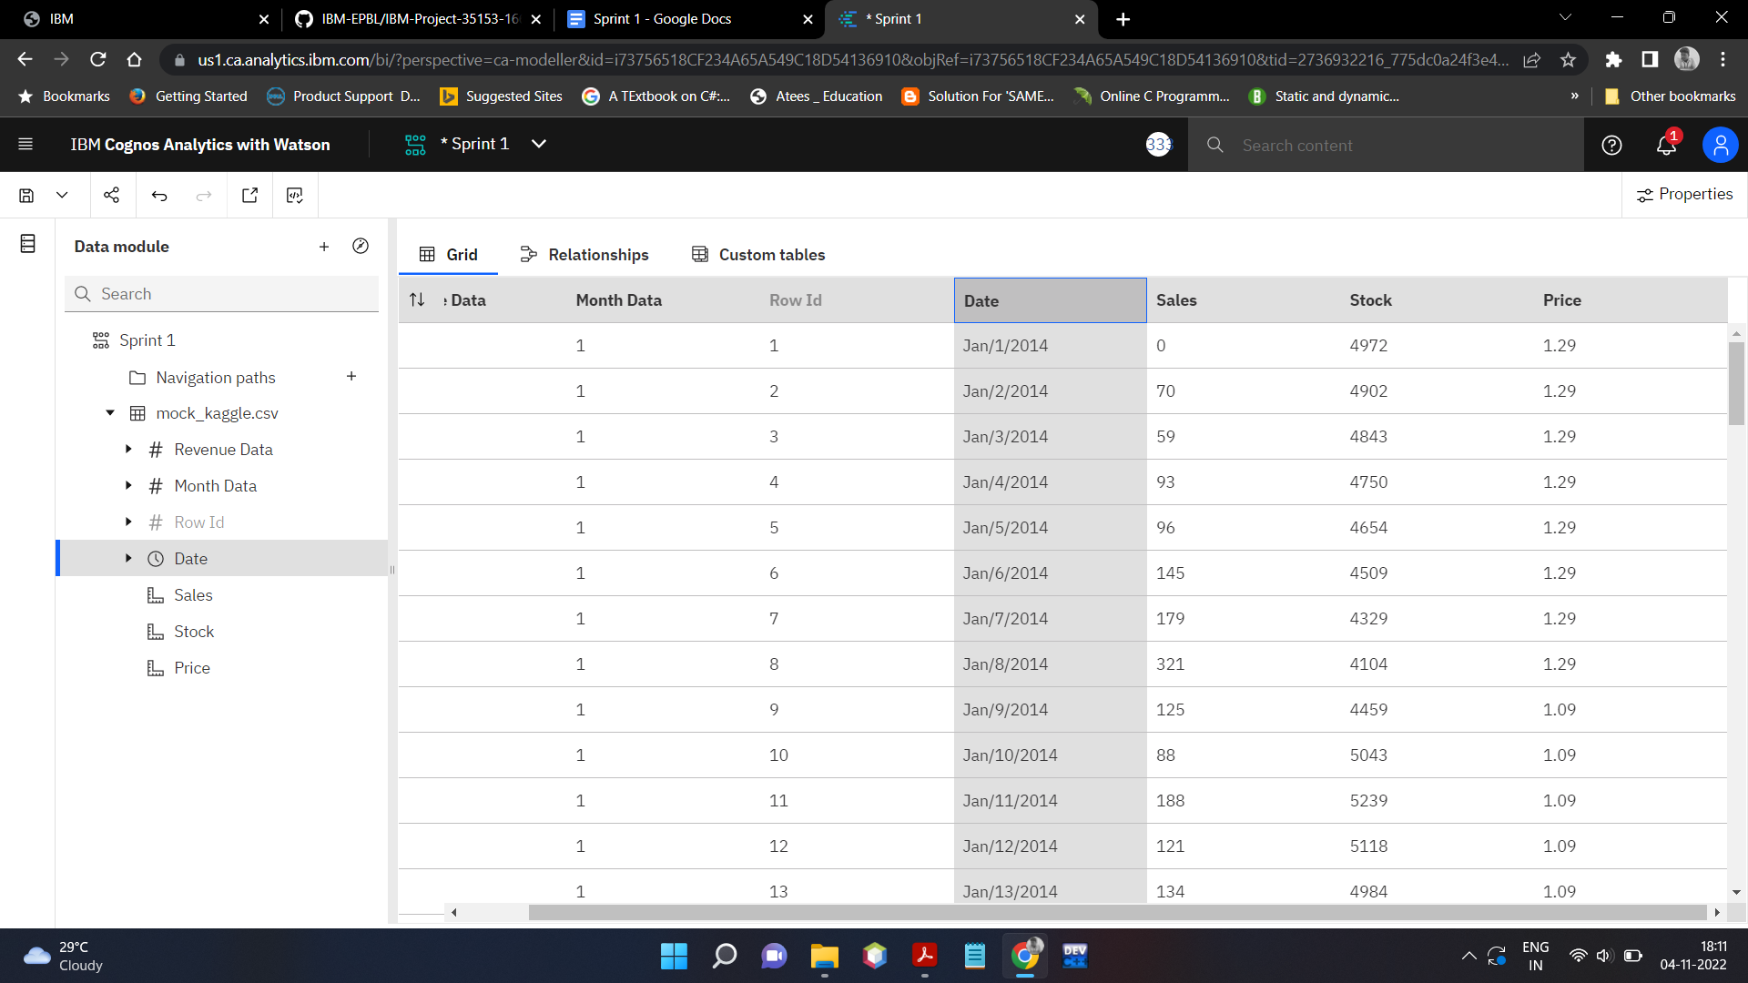

**Stock Data:**

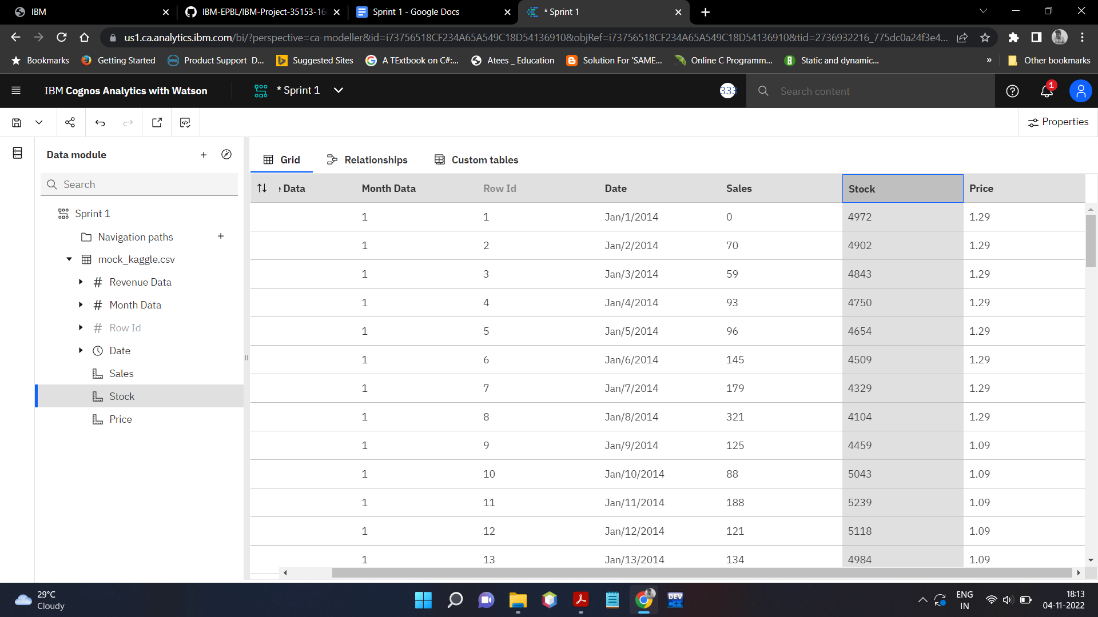

**Price Data:**

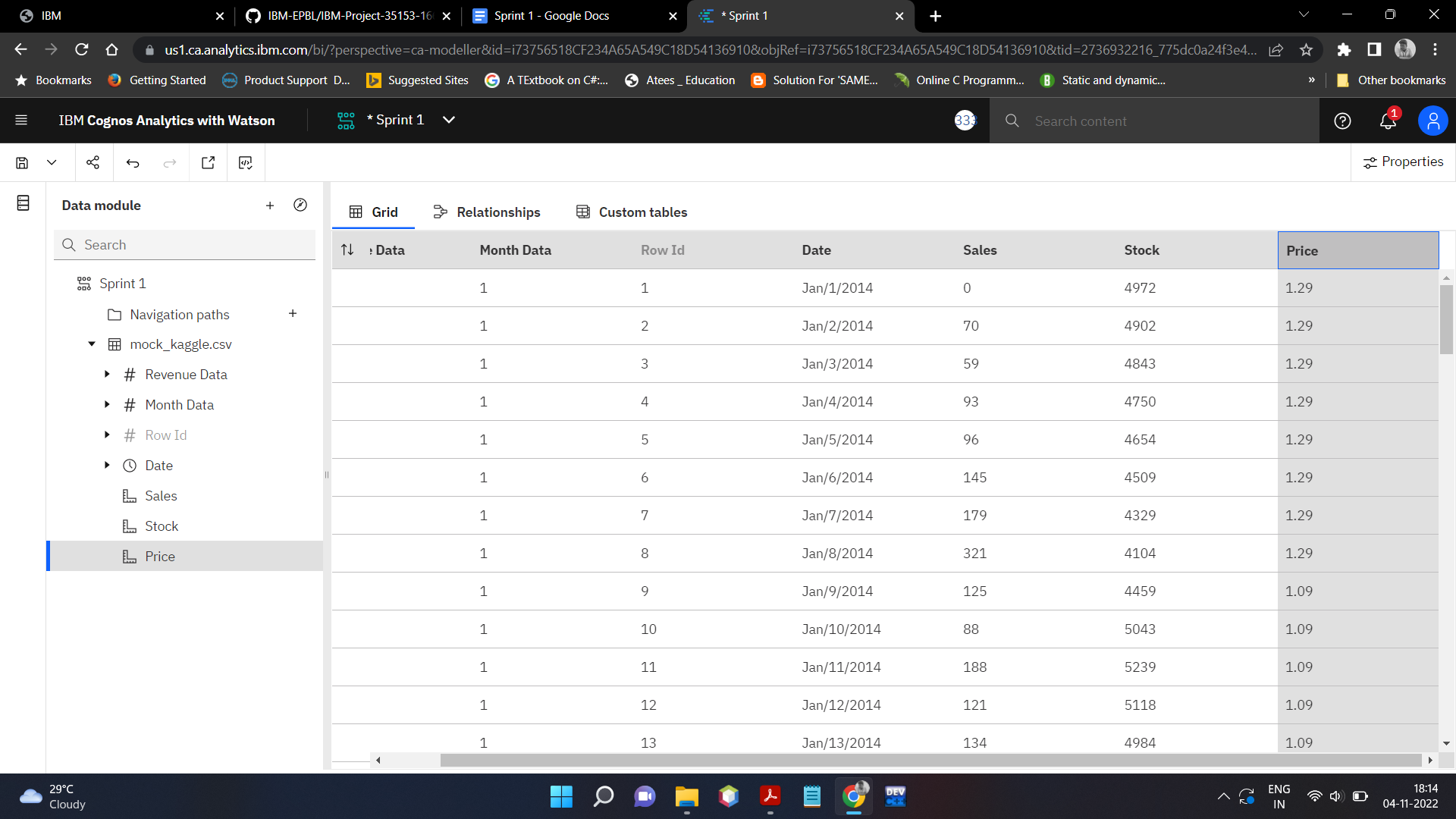

**Sales Data:**

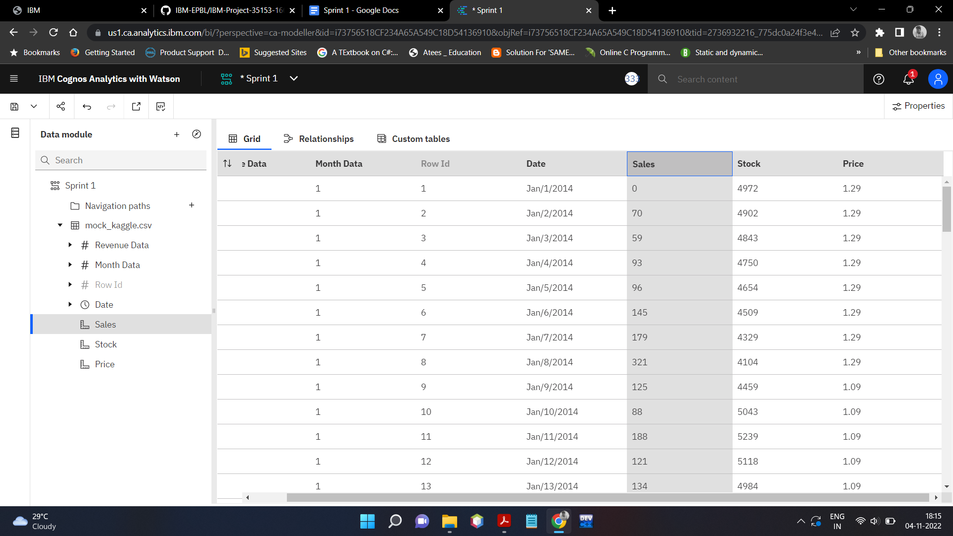

**Month Format Data:**

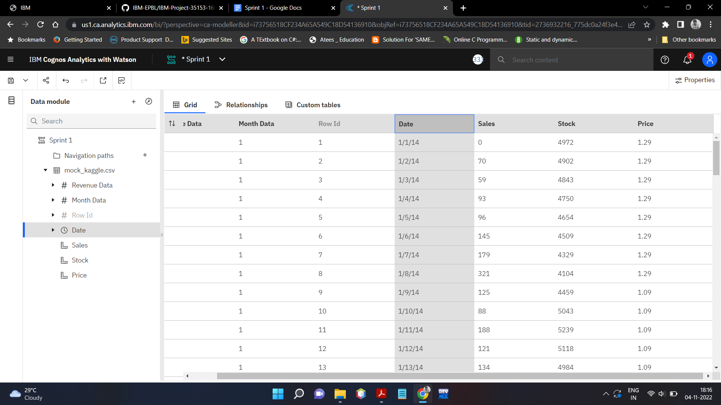

**Year Format Data:**

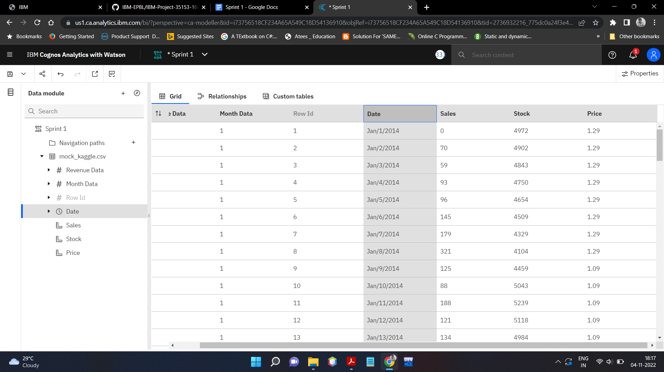

**Stock Format Data:**

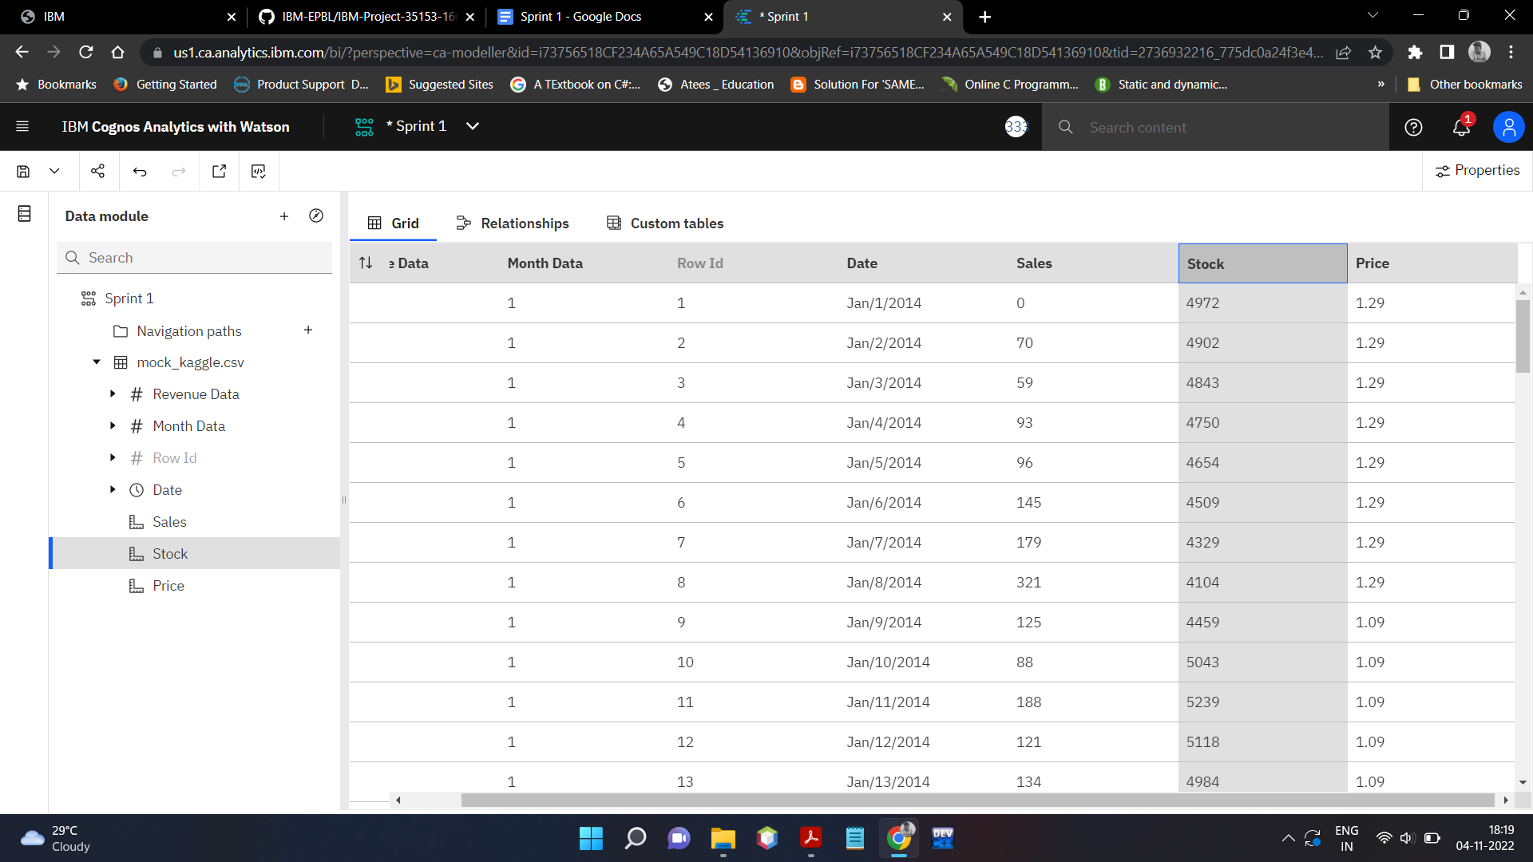

**Sales Format Data:**

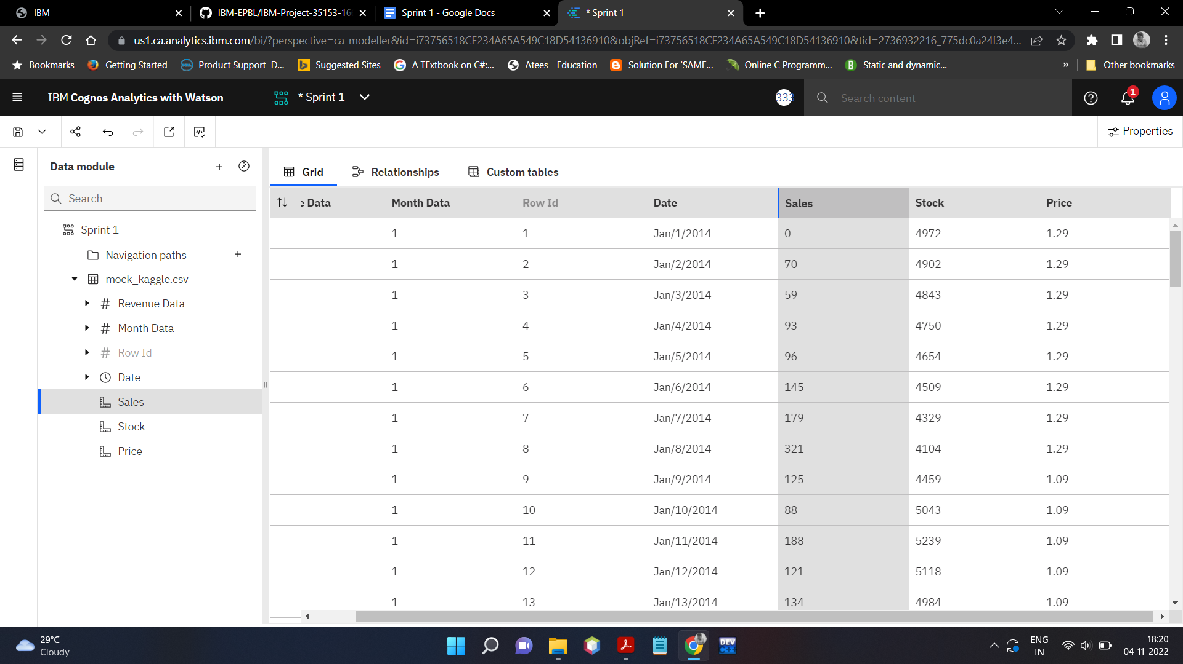

**Price Format Data:**

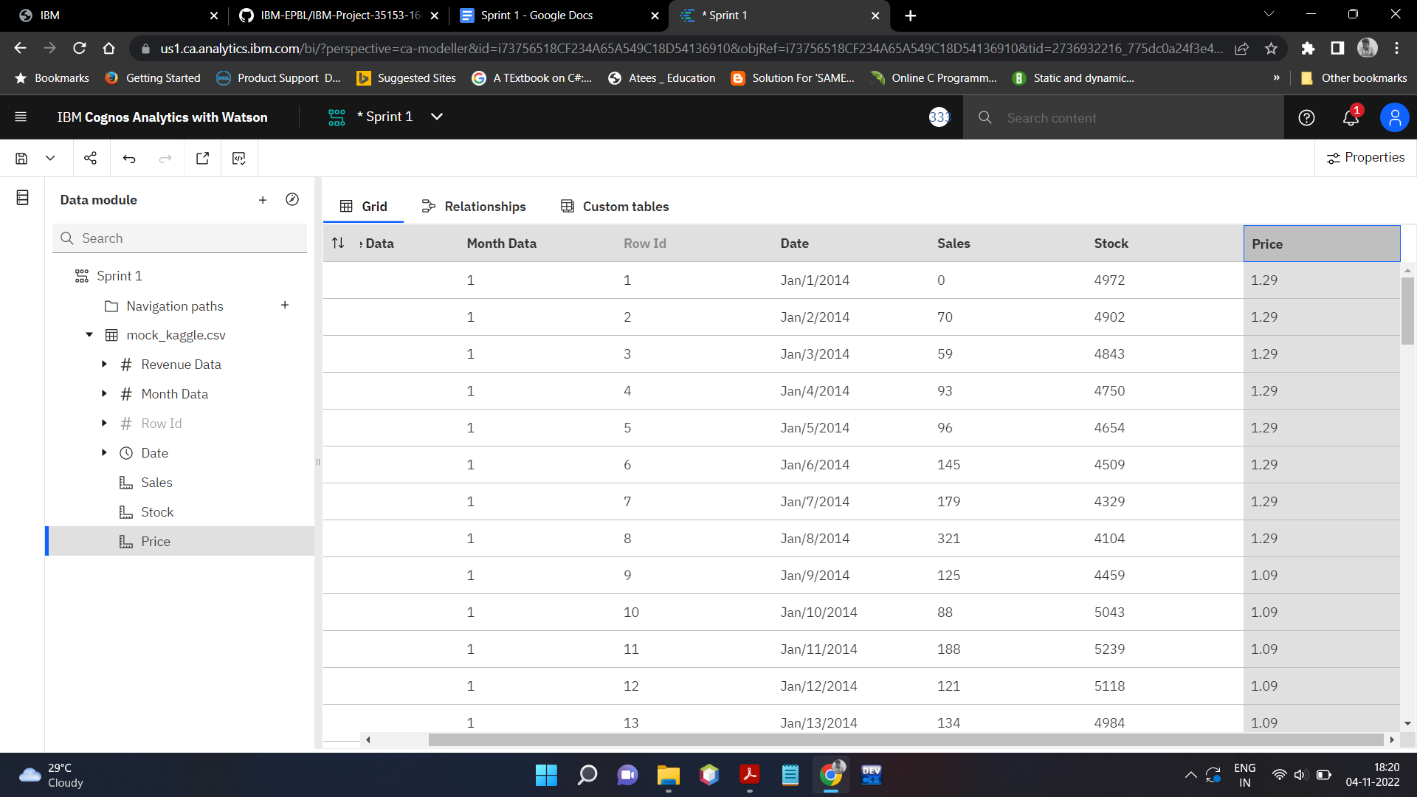

**Revenue Format Data:**

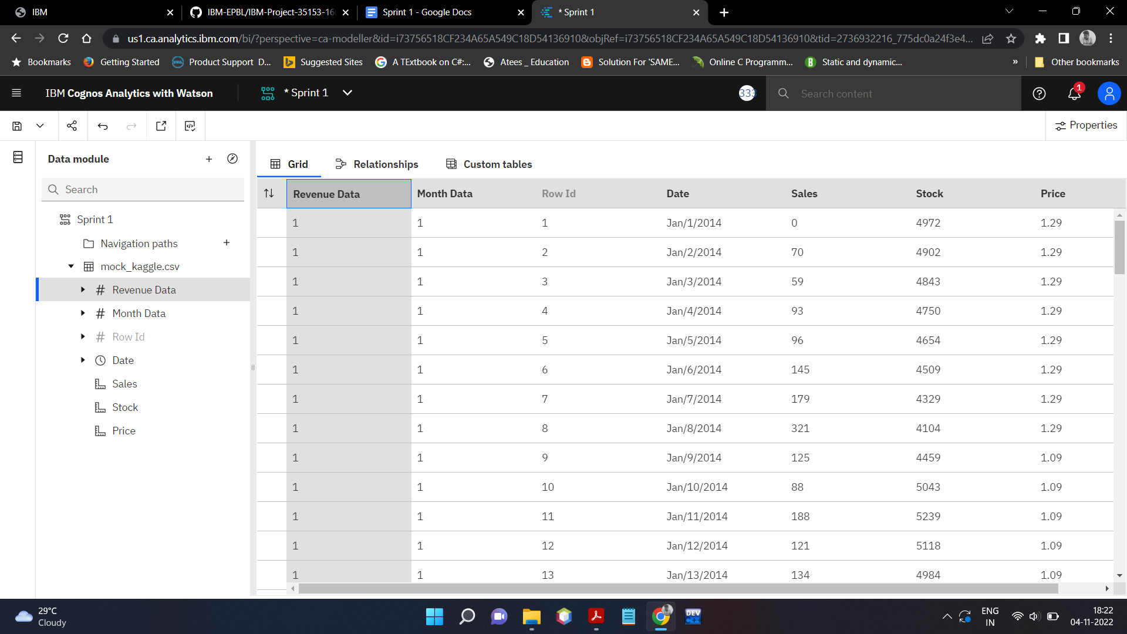

**Cognos Link:**

[**https://us1.ca.analytics.ibm.com/bi/?perspective=ca-modeller&pathRef=.my_folders%2FSprint%2B1**](https://us1.ca.analytics.ibm.com/bi/?perspective=ca-modeller&pathRef=.my_folders%2FSprint%2B1)